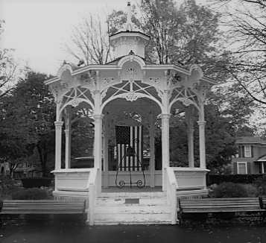**VILLAGE OF BELLVILLE**

142 PARK PLACE

BELLVILLE, OHIO 44813

419 886-2245 EXT 1

Village of Bellville, Ohio

Public Records Request

The Village of Bellville believes an open government is an important principle of democracy.

While not mandatory, please fill out this form so it will help us provide the public records you are requesting in a timely fashion.

**Name of Requester**:__________________________________________________

**Street Address:**______________________________________________________

**City**:______________________________ **State**:_____________________ **Zip**:_________________

**Phone**:____________________________ **Today’s Date**:__________________________________

**Signature**:___________________________________________________________

Please describe what records you want to review and be as specific as possible. Please print.

Bellville Staff Handling Request_________________________________________

Date request completed______________________________________________